If you're looking for healthy first birthday cake recipes, then you've found the perfect place! These recipes are **sugar free** - yes, it IS possible to make a yummy cake for your baby without adding any table sugar at all!   
  
  
Your baby will probably have been introduced to most of the ingredients in these recipes by his first birthday - with the possible exception of [eggs](http://www.homemade-baby-food-recipes.com/when-can-my-baby-eat-eggs.html).

If your baby has NOT been introduced to whole eggs, then you might like to think about giving them to him just prior to his birthday. If they *do* trigger any kind of reaction in your little one, at least you'll be aware of this beforehand. It would be awful to have him experience any problems caused by his birthday cake!

You may notice that some of our recipes for baked foods call for salt. Ordinarily, of course, we wouldn't recommend adding salt to baby food ([here's why](http://www.homemade-baby-food-recipes.com/adding-salt-to-baby-food.html)) - but in some recipes salt is necessary because it reacts with baking powder to help the product rise!   
  
  
**Healthy First Birthday Cake Recipes - Sugar Free Applesauce and Banana Cake** 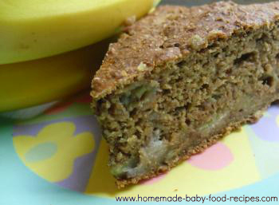  
  
8 oz (2 cups) whole wheat flour   
1 tbsp [wheat germ](http://www.homemade-baby-food-recipes.com/wheat-germ.html)   
1 heaped tsp baking soda   
1 tsp cinnamon (optional)   
6 medium, ripe [bananas](http://www.homemade-baby-food-recipes.com/banana-baby-food.html) - mashed   
8 fl oz (1 cup) [sugar-free applesauce](http://www.homemade-baby-food-recipes.com/fruit-baby-food-recipes.html#applesauce)   
2-4 fl oz (1/4 to 1/2 cup) soy milk   
  
  
Preheat the oven to 325 deg F (160 deg C).   
In a bowl, combine the flour, wheat germ, baking soda and cinnamon.   
In a separate bowl, combine the applesauce with the mashed bananas and 1/4 cup milk.   
Pour the applesauce mixture into the bowl with the dry ingredients and mix thoroughly. If the mixture seems dry, you can add up to another 1/4 cup milk.   
Pour into a greased 9" x 9" square or 9" round pan and bake for around 1 to 1 1/2 hours. The cake is ready when a sharp knife inserted into the middle comes out clean.   
[[Print Friendly and PDF](http://www.printfriendly.com/)Print Friendly](http://www.printfriendly.com)   
  
  
**Healthy First Birthday Cake Recipes - Sugar Free Carrot Cake** 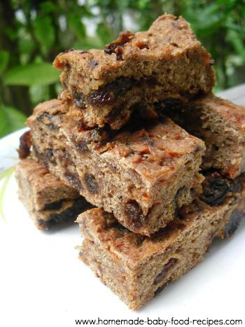  
  
This cake is deliciously dense and fruity and our children love it still... many of them way beyond their first birthday!   
  
8oz (2 cups) whole wheat flour   
1tsp baking powder   
1tsp baking soda   
pinch salt   
10 fl oz (1 1/4 cup) water   
6oz (3/4 cup) [raisins](http://www.homemade-baby-food-recipes.com/when-can-my-baby-eat-raisins.html)   
6oz (3/4 cup) sultanas   
1tsp cinnamon   
1/2tsp nutmeg   
8oz (1 cup) [carrot](http://www.homemade-baby-food-recipes.com/carrot-baby-food.html), grated   
4 fl oz (1/2 cup) [sugar-free applesauce](http://www.homemade-baby-food-recipes.com/fruit-baby-food-recipes.html#applesauce)   
  
  
Preheat the oven to 375 deg F (190 deg C).   
Combine the flour, baking soda, baking powder and salt in a bowl.   
Pour the water into a small saucepan and add the raisins, nutmeg, cinnamon and sultanas.   
Bring the mixture to a boil, then lower the heat and simmer for 5 mins.   
Put the grated carrots into a bowl, then pour in the liquid mixture. Then, add the applesauce and stir the mixture thoroughly.   
Mix the wet ingredients with the dry ingredients and stir thoroughly.   
Pour the mixture into a greased pan and bake for 45 mins to 1 hour, until a sharp knife inserted into the centre comes out clean.

*Note: We usually use an 8" pan for this recipe, but in our picture, we used a 10" square pan to create a thinner cake that we could cut into fingers. If you wish to do the same, then reduce the cooking time to 30 to 45 mins.*   
[[Print Friendly and PDF](http://www.printfriendly.com/)Print Friendly](http://www.printfriendly.com)   
  
  
**Healthy First Birthday Cake Recipes - Spiced Banana Cake With Dried Fruit**   
  
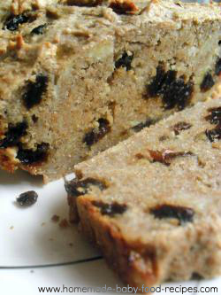8oz (2 cups) whole wheat flour   
4oz (1/2 cup) raisins   
2oz (1/4 cup) sultanas   
4oz (1/2 cup) butter   
1tsp cinnamon   
2 eggs, beaten well   
3 medium [bananas](http://www.homemade-baby-food-recipes.com/banana-baby-food.html), mashed   
  
  
Preheat the oven to 360 deg F (180 deg C).   
Rub the butter into the flour until the mixture looks like breadcrumbs, then stir in the cinnamon.   
Next, stir in the mashed banana, beaten eggs and dried fruit.   
Pour the mixture into a greased loaf tin.   
Bake for around 1 to 1 1/4 hours, until a sharp knife inserted into the centre comes out clean.   
[[Print Friendly and PDF](http://www.printfriendly.com/)Print Friendly](http://www.printfriendly.com)   
  
  
  
**Healthy First Birthday Cake Recipes - Banana and Blueberry Cake**   
  
What we love about this recipe - apart from the fact that it tastes AMAZING - is that there are no complicated techniques involved in its preparation. You just put everything in one bowl, mix it all together, and you're done! If you have little baking experience and you're worried about making a mess of baby's first birthday cake, then this is the recipe to try - it's almost foolproof!

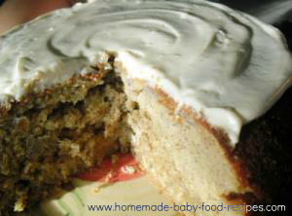4 oz (1 cup) old fashioned rolled oats   
5 oz (1 1/4 cups) whole wheat flour   
4 oz (1 cup) all purpose flour   
1 tsp baking soda   
2 tsp baking powder   
2 1/2 tsp cinnamon   
good pinch of salt   
6 medium ripe bananas, peeled and mashed   
4 fl oz (1/2 cup) unsalted butter, melted   
1/2 cup blueberries, chopped (use fresh, or frozen berries thawed and drained)   
4 eggs, beaten well   
6 fl oz (3/4 cup) frozen unsweetened apple juice concentrate, thawed*

*You can use regular apple juice concentrate instead for a sweeter result, but do bear in mind that the recipe will be a higher in sugar than if you use the unsweetened variety.   
  
  
Preheat the oven to 350 deg F (175 deg C).   
Put the first seven ingredients into a large bowl and mix them together.   
Add all the rest of the ingredients and stir well until thoroughly combined.   
Grease a 9 inch cake tin and pour in the mixture.   
Bake for around 50 mins to one hour, until a sharp knife inserted into the centre comes out clean.   
Cool in the tin for 20 mins, then turn out on a wire rack to cool completely.

**To make the cream cheese frosting in the photograph...**

Stir together one 3 ounce package of cream cheese, 1/4 tsp of vanilla and 2 1/2 tbsp regular frozen apple juice concentrate (thawed). Spread over the top of the cake once it's cool.   
[[Print Friendly and PDF](http://www.printfriendly.com/)Print Friendly](http://www.printfriendly.com)   
  
  
  
**Healthy First Birthday Cake Recipes - Organic Honey and Ginger Loaf**   
  
Here's a wonderful recipe for your baby food connoisseur! This cake is sweetened with honey (*please note that this recipe should NOT be used for babies under one year of age*) and has a warming, spicy flavour (as in spicy-aromatic, not spicy-hot!). The texture is deliciously moist and the recipe calls for 100% whole wheat flour, so it contains plenty of whole grain goodness for baby and friends!

*Note - we cheated a little with this one for presentation purposes as it's topped with a very fine dusting - less than 1/4 teaspoon - of confectioner's (icing) sugar. This, of course, is not at all essential to the recipe and can be omitted or replaced with a sugar free frosting.*

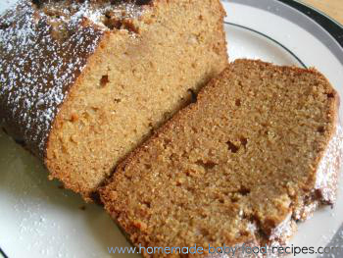10 oz (2 1/2 cups) whole wheat flour   
6 oz (3/4 cups) unsalted butter, softened   
8 oz (1 cup) organic honey   
2 eggs   
8 fl oz (1 cup) milk   
2 tsp baking soda   
1 tsp cinnamon   
1 tsp nutmeg   
1 tsp ground ginger   
  
  
Preheat the oven to 325 deg F (165 deg C).   
In a bowl, combine the softened butter with the honey.   
Beat in one egg. When thoroughly incorporated, beat in the second egg.   
Pour in the milk and mix well.   
In a separate bowl, mix the flour, baking soda and spices.   
Combine the dry ingredients with the wet, stirring until just smooth.   
Pour mixture into a greased loaf pan.   
Bake for around one hour, until a sharp knife inserted into the centre comes out clean.   
Cool in the tin for 10 mins, then turn out on a wire rack to cool completely.

If you wish to use the confectioner's sugar as a topping, sprinkle on once the cake is cool.   
[[Print Friendly and PDF](http://www.printfriendly.com/)Print Friendly](http://www.printfriendly.com)

Why not make a delicious frosting for baby's cake using our

[Sugar-Free Frosting Recipes](http://www.homemade-baby-food-recipes.com/sugar-free-frosting.html)

Want to make baby's cake look extra special with only natural and healthy ingredients? Learn how to make

[Homemade Food Coloring](http://www.homemade-baby-food-recipes.com/homemade-food-coloring.html)

Is your baby on a wheat free diet?

[Check out our Wheat Free Birthday Cake Recipes](http://www.homemade-baby-food-recipes.com/wheat-free-birthday-cake-recipes.html)

Fancy something completely different for baby's first birthday?

[Check out the fab Fruit Pizza recipe on our blog](http://blog.homemade-baby-food-recipes.com/healthy-fruit-pizza-an-alternative-to-cake-for-babys-first-birthday/)

Read more: <http://www.homemade-baby-food-recipes.com/healthy-first-birthday-cake-recipes.html#ixzz3EGEfJFNj>